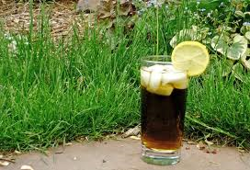

Nettles & Peppermint Iced Tea
Summer makes you want to have pitchers of iced tea on hand. While a nice cold glass of black or green tea on cubes is refreshing, a nettle-peppermint infusion over ice offers a some additional healing benefits. It is rich in vitamins A, C, iron, potassium, magnesium and calcium and it can be used to treat everything from eczema to arthritis. It also supports the liver. You can read more in my article on Nettles.
3 Tb dried nettles or 4 tea bags
1 Tb dried peppermint or 2 tea bags
3 c filtered water
A pitcher filled with ice
1 lemon
Method:
Put the nettle and peppermint into a mason jar. Boil the water and pour it over the nettle and peppermint. Cover and let the mixture sit overnight.
In the morning, fill your pitcher with ice and pour in the tea. Let the tea rest on the counter for 30 minutes so that some of the ice melts and dilutes the tea. Pour into glasses and garnish lemon.
This is a strong glass of tea. It is also awesome mixed with green and black iced teas.

